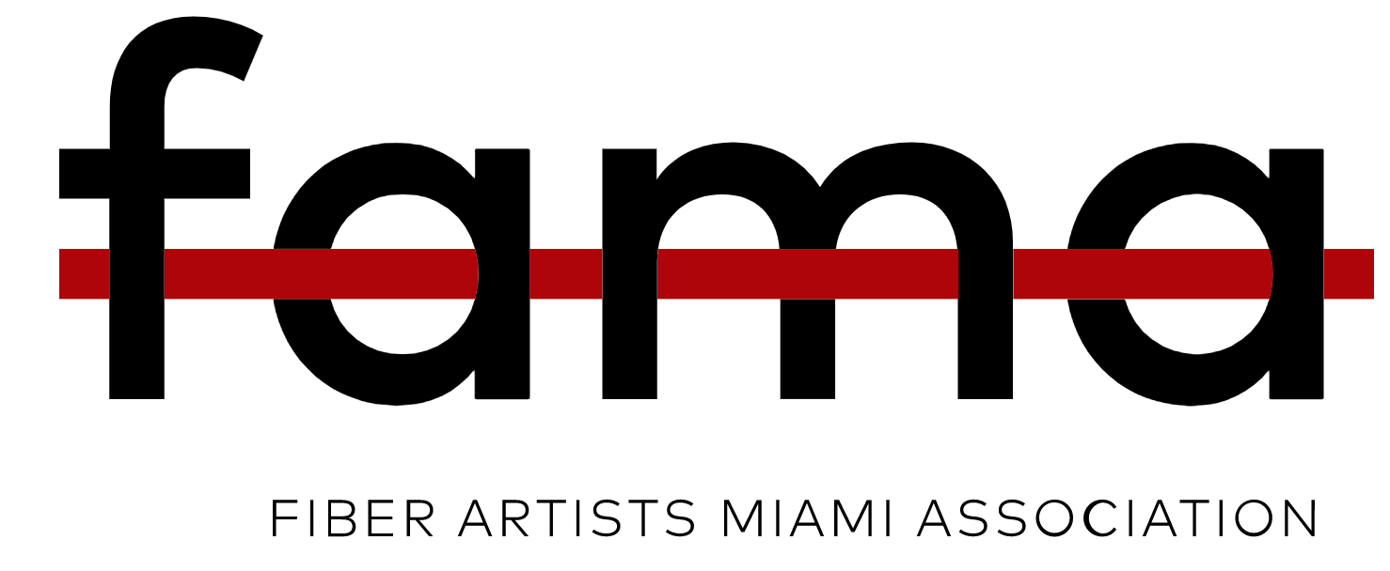
Miami, Florida-October 24, 2022- Threading the City Celebrates Miami and the Burgeoning of the World of Textile Arts.
A great range of experimental textile art exhibitions, workshops, lectures, studio visits, installations, and events will thread across Miami from October-January 2022. Threading the City is a fusion of the Fiber Artists Miami Association (FAMA) and Aluna Art Foundation, Artnezs, Little River, The CAMP Gallery, North Miami, HARTVEST Project @ Pinecrest Gardens, Pinecrest, The Museum of Contemporary Art of the Americas, formerly known as Kendall Art Center, Piero Atchugarry GalleryMiami Design District, Art Seen 365, RTCurated, Instituto Cultural de Mexico Miami at the Consulado General de Mexico, Miami, Partners for Art & Design, and World Textile Art (WTA), and the Collective 62, Liberty City.
The city-wide events are an investment in economic, cultural, and social platforms that revitalize and showcase the extraordinary talent of local and international textile artists.
FAMA, a nonprofit corporation, its founders Aurora Molina, Evelyn Politzer, and Alina Rodriguez Rojo announce over twenty programs and events with the mission to educate, advance, and elevate textile traditions and contemporary fiber arts.
-Adriana Herrera, PhD, co-founder of Aluna Art Foundation, will lead talks on the influence of pre-Hispanic textile legacy on modern and contemporary textiles, all funded by the Florida Humanities with funds from the National Endowment for the Humanities.
- ARTNEZS Portals is an 11-person exhibition and workshop series with artist and designer-led programs in a green space adjacent to Laura Marsh’s studio that explores the relationship between natural and synthetic fibers and social practice. Other topics include displacement, transience, artist advocacy, and humanitarianism explored through site-specific installations and sculptures.
-The 2022 edition of Women Pulling at the Threads of Social Discourse looks back to Virginia Woolf’s A Room of One’s Own, written in a time when women were barred from exercising their innate freedom. “There is no gate, no lock, no bolt that you can set upon the freedom of my mind.” This exhibition, A Room of Our Own, will transform The CAMP Gallery’s North Miami space into a room made entirely of fiber, becoming the embodiment of personal freedom. -Melanie Prapopoulos, director, The CAMP.
- Carola Bravo, PhD., curates Life at Street Level, a provocative exhibit that interweaves fiber with photography, photo collage, and installation works to capture an instant view of Miami at the street level that conveys urban resilience.
-Piero AtchugarryGallery Gallery presents the Ámate installation by Karla Kantorovich, curated by Rina Gitlin and a related art talk.
-The Museum of Contemporary Art of the Americas, formerly known as Kendall Art Center exhibits Subverting Materials: Fiber and Textile Art by Women Artists curated by Francine Birbragher, PhD.
- Cultural Institute at the Consulate General of Mexico in Miami, explores The Migrant Experience shining a light on our cultural map. Curated by Rina Gitlin and Adriana Torres Sánchez.
Threading the City coexists with the World Textile Art (WTA) X Biennial, Doral, and Coral Gables. WTA celebrates 25 years of its WTA Biennials held in the US, Venezuela, Costa Rica, Argentina, Mexico, Uruguay, Spain, and Chile. WTA selected Miami as its X Biennial venue, naming Luis Valenzuela as hosting Miami director. Pilar Tobon, CEO of WTA has projected the participation of artists from more than 30 countries for this biennial. FAMA will thread Miami from the east to the west, supported by a team of creative initiators and their collective experiences to unite the community in dialogue to demystify and advance the world of contemporary textile art.
Contacts
FAMA: fiberartmiamiassociation@gmail.com/ Co-founders Aurora Molina, Evelyn Politzer, Alina Rodriguez-Rojo. Subject Line: Threading the City
Calendar of Events: Dainy Tapia, ArtSeen365, dainy@artseen365.com/ Instagram@art.seen.365
WTA: World Textile Art, WTA, Biennial Director: Luis Valenzuela; Valenzuelaclass@gmail.com, President: Pilar Tobon
Art Openings
Friday, October. 21, 2022, 5-7 PM. Opening, Artnezs, Little River, Portals Artists: Anna Biondo, Veronica Buitron, Mabelin Castellanos, Karen Schnell-Chisholm, Yanira Collado, Orly Kadosh, Karelle Levy (Krelwear), Marcia Manconi, Laura Marsh, Carmen Vicente, Pangea Kali Virga. Curator: Artnezs (Laura Marsh), Contact: artnezsart@gmail.com. Address: 66 NW 84 St, Miami, FL 33150, 305-780-1650, Hours of operation: Mon.-Thur. 10-4 pm and by appointment. On view: Oct. 21-Dec. 9. instagram.com/artnezs.
Free and open to the public.
Thursday, October 27th, 2022, 7 pm, Opening, Cultural Institute at the Consulate General of Mexico in Miami, In Search of Dreams, The Migrant Experience, Artists: Bobbi Baugh, Sharon Berebichez, Nancy Billings, Liene Bosquê, Melani Brewer, Mabelin Castellanos, Maruchi Carmona, Perla Gonzalez, Mila Hajjar, Andrea Huffman, Shelly McCoy, Aurora Molina, Vero Murphy, Alicia Rodriguez, Debora Rosental, Maya Schonenberger, Silvana Soriano, Marilyn Valiente, Laura Villareal. Curators: Rina Gitlin/ RTcurated and Adriana Torres Sánchez. rinagitlin@gmail.com. Address: 1399 SW 1st Avenue, Miami, FL 33130. Hours of operation Mon- Fri 10:00 am-5:00 pm. On view: October 27, 2022-November 10, 2022. Closing and Workshop with artist Aurora Molina on November 10, 2022. Free and open to the public
Friday, October 28, 2022, 6-9 pm, Opening, The CAMP Gallery, North Miami, Women Pulling at The Threads of Social Discourse: A Room of One's Own, Artists: Aida Tejada, Alina Rodriguez Rojo, Alissa Alfonso, Amy Gelb, Angela Bolanos, Anna Biondo, Aurora Molina, Carolina Romeo, Debora Rosental, Donna Ruff, Evelyn Politzer, Grayson Beaulieu, Jeannette Gonzalez-Crato, Joan Wheeler, Juliana Torres, Karina Hovaghimian, Laetitia Adam - Rabel, Laura Villareal, Liene Bosquê, Lisa Rockford, Lydia Viscardi, Mabelin Castellanos, Margaret Roleke, Marilyn Valiente, Maru Ulivi, Mirele C C Volkart, Monica Avayou, Monica Czukerberg, Natalia Schonowski, Natalie Plasencia, Orly Kadosh, Paola Mondolfi, Patricia Cooke, Patty Suau, Rita Valley, Sandra Onetti, Sharon Berebichez, Shelly McCoy, Shirley Chong, SIlvana Soriano, Silvia Yapur, Sofia Jacobs, Sooo-z Mastropietro, Star Trauth, Tatiana Zaytseva. CURATORS: : Melanie Prapopoulos, AND Maria Gabriela Di Giammarco. Contact: info@thecampgallery.com, The CAMP Address: 791 NE 125th St. North Miami, FL 33161. 786-953-8807. Hours of operation: Wed.-Sat. 11-5 On view October 28-December 10, 2022, Instagram: thecampgallery/. Free and open to the public
Thursday, November 3, 2022, 7-10 pm, Wta-online.org, World Textile Art 10th Biennial opening night, Miami International Fine Arts (MIFA), 7 to 10 pm, 5900 NW 74th Ave, Miami, FL 33166. The exhibition will be open to the public from Nov 4 to Dec 10. Hours: Monday through Friday, 9:30 am to 4:30 pm, Saturdays 9:30 to 4:00 pm. Free and open to the public
Friday, November 4, 2022, 7-10 pm, Visit Wta-online.org World Textile Art Private Collection exhibition opening night. Colombia General Consulate, 7 to 10 pm. 280 Aragon Ave, Coral Gables, FL 33134. Free and open to the public
Friday, November 11, 2022. 6-11 pm, Opening, The Museum of Contemporary Art of the Americas, (MoCAA), formerly known as Kendall Art Center, Kendall, Subverting Materials: Fiber and Textile Art by Women. Artists. Aimée García, Aimée Pérez, Allison Kotzig, Evelyn Politzer, Ivonne Ferrer, Karla Kantorovich, Liberty Worth, Milena Martínez-Pedrosa, Valerie Lustgarten. Director: Odette Lopez, Curator: Francine Birbragher, PhD., fbirbragher@gmail.com, Address: 12063 SW 131st Ave, Miami, FL 33186. 305-778-7739 / 305-763-9242, Hours of operation: Monday-Friday 12-5 pm. On view: November 11, 2022- January 6, 2023. Talk organized by Aluna Art Foundation, Friday, November 11, 5 pm, Sponsored by the Florida Humanities Council. Free and open to the public
Saturday, November 12, 2022, 11 am-2 pm, Opening/ Event Saturday, November 19, 6-8 pm, HARTVEST Project @ Pinecrest Gardens, Life at Street Level (Cypress Hall), and Nature and History, (outdoor sculptures by the bird cages and exterior site-specific installation). Artists: Alissa Alfonso, Sharon Berebichez, Nancy Billings, Liene Bosque, Carola Bravo, RemiJin Camping, Maritza Caneca, Marco Caridad, Mabelin Castellanos, Alex De Yavorsky, Jocelyn Flores, Amy Gelb, Isabel Infante, Jeanne Jaffe, Marlene Kohn, Oriana Lacau, Adriana Lo Mascolo, Aurora Molina, Paola Mondolfi, Vero Murphy, Juliana Navarro Torres, Cynthia Passavanti, Evelyn Politzer, Felisa Prieto, Rosario Salazar, Debora Rosental, Denise Shapiro, Silvana Soriano, Laura Villarreal y Mirele Volkar. Raffles and yarn tossing sponsored by Malabrigo. Curator: Carola Bravo, Ph.D., Address: 11000 SW 57th Ave, Pinecrest, FL 33156, Hours of operation: Hours of operation Mon- Fri 10:00 am-5:00 pm. On view through Jan. 31, 2022. Contact: carolabravoarte@gmail.com. Free and open to the public
Talks and Lectures
Friday, November 4, 2022, 5 pm-7:30 pm, Artist Talk-Paula Kovarik, a nationally-recognized textile artist with an expertise in free-motion quilting. Paula will share her artistic journey, her unique approach, process, and her creative inspirations. Presentation by Kovarik is followed by a wine and cheese reception, all sponsored by Partners for Art + Design. Address: St. Mary's, 136 Frow Avenue, Coral Gables. Reservation. Free with reservation
Florida Humanities awarded a Community Project Grant Award to Aluna Art Foundation for the public programming of Threading the City. Lead scholar Adriana Herrera, Ph.D., joins other invited scholars, including: Carol Damian, Ph.D., Carola Bravo, Ph.D., Francine Birbragher Ph.D., and Shelley Burian, Ph.D. Topics to be explored include the Pre-Hispanic origins of modern and contemporary fiber art and its continued presence in Latin America as well as sociopolitical uses of textile art in the 21st century. Florida Humanities-supported programming in conjunction with Threading the City are free and open to the public. Funding for this program was provided through a grant from Florida Humanities with funds from the National Endowment for the Humanities. Any views, findings, conclusions or recommendations expressed in these programs do not necessarily represent those of Florida Humanities or the National Endowment for the Humanities.
Saturday, October 22, 2022, at 3:00 pm: First in a series of talks by Dr. Adriana Herrera is Threading Textile Times which will take place at Piero Atchugarry Gallery under artist Karla Kantorovich's immersive installation Ámate, curated by Rina Gitlin. Dr. Herrera, co-founder of the Aluna Art Foundation, will lecture on the influence of the legacy of pre-Hispanic textiles on modern and contemporary textile art in Europe and the United States. Her presentation includes examples of this legacy in the work of prominent artists throughout the continent and mentions of local artists who extend the thread of that influence. The talk will culminate with a dialogue on how artist Karla Kantorovich's installation Ámate, contains cues from Mesoamerican ancestral cultures in her contemporary artistic language. Piero Atchugarry Gallery, 5520 NE 4 Avenue, Free with Reservation
Friday, November 11, 2022, from 5 pm to 6 pm: A conversation with a group of local artists participating in the exhibition Subverting Materials: Fiber and Textile Art by Women Artists, curated by Dr. Francine Birbragher for the Museum of Contemporary Art of the Americas, with works by Aimee García, Aimee Pérez, Allison Kotzig, Evelyn Politzer, Ivonne Ferrer, Karla Kantorovich, Liberty Worth, Milena Martínez-Pedrosa, and Valerie Lustgarten. The Miami-based artists will dialogue about the ancestral and contemporary representation of women's fiber art. Address: The Museum of Contemporary Art of the Americas, 12063 SW 131st Ave, Miami, FL 33186. Contact: 305-778-7739. Free and open to the public
Zoom Talk | November 17, 2022, from 4 pm to 5 pm: Threading the City's virtual panel discussion features art historian and Pre-Columbian art experts Carol Damien, Ph.D., and Shelley Burian, Ph.D., moderated by Adriana Herrera, Ph.D. The discussion, titled Circularity of Textile Time will explore the relationship between pre-Hispanic textiles and modern fiber art and will examine the living presence of indigenous art not only in contemporary artists who are direct descendants of native peoples, but also in other Latin American artists, including some Miami artists who work with fiber. Contact: ZOOM, Meeting ID: 864 9004 7780, Passcode: 825765 Free and open to the public
December 3, 2022, at 5:00 pm: Pinta Art Fair. As part of the PINTA TALKS during PINTA Miami 2022, a conversation with local artists Pip Brant, Aurora Molina, and Evelyn Politzer, moderated by Adriana Herrera Ph.D., will reflect aspects of politically charged fiber arts, and ways of exploring the relationship between history, ancestral fiber traditions, and contemporary textile art. Free and open to the public
December 10, 2022 at 12:00 pm: Dr. Adriana Herrera will also offer a public talk at the exhibition Braiding Times, at Tanya Brillembourg Art, Key Biscayne. The exhibition, curated by Aluna Curatorial Collective showcases Guatemalan contemporary art made by the Mayan descendant artists Antonio Pichilla, tepeu choc, and Manuel Chavajay. The talk will increase the knowledge and recognition of Native American strength in contemporary fiber art. Free and open to the public
January 15, 2023, from 11:00 am to 12:00 pm: A guided interpretive tour of Life at Street Level, by artist Carola Bravo, Ph.D., and Adriana Herrera. The event will be hosted by The Hartvest Project at Pinecrest Gardens. Life at Street Level is an exhibit curated by Dr. Carola Bravo, that interweaves fiber with photography, photo collage, and installation works to capture an instant view of Miami. Artists: Maritza Caneca, Evelyn Politzer, Jeanne Jaffe, Alissa Alfonso. Hartvest Project, Address: 11000 SW 57th Ave, Pinecrest, FL 33156, Contact: carolabravoarte@gmail.com. Free and open to the public
Friday, February 3, 2022, launching of educational video produced by curator Adriana Herrera, PhD. regarding the influence of Native American textiles on the development of modern and contemporary fiber art in Europe and America, with a segment on local textile artists living in Miami. Contact: fiberartmiamiassociation@gmail.com/ http://fiberartmiamiassociation.com/. Free and open to the public

Workshops
Wednesday, October 5, 2022, 9 am-3 pm, Miami Dade College Hialeah Campus Gallery, Reimagining and Transformation, The Work of Jeanne Jaffe, Mixed media construction, storytelling, performance, and video. Address: 1780 W 49 St. Hialeah. To register contact president@dadearteducators.org. Free and open to the public
Wednesday, November 2, 2022, 11-2:30 pm, Artnezs, El Portal, Introduction to Natural Bundle Dyeing with Veronica Buitron, $$. Contact Artnezs directly, For registration contact artnezsart@gmail.com or https://www.lauramarsh.net/artnezs and on Instagram
November 4-6, 2022, 9 am-4 pm, Partners for Art & Design, A Play in the Garden of Stitch with Paula Kovarik. Address: St Mary's 136 Frow Avenue, Coral Gables, $$, motion quilting, and composition registration required in advance, with limited seats.
Thursday, November 10, 2022, 6 pm, Cultural Institute at the Consulate General of Mexico in Miami. Combine your love of textiles with your belief in social justice in this workshop with Artist Aurora Molina, So (sew) America Cares, Open to children and adults, Register: contact rinagitlin@gmail.com. Free and open to the public
Saturday, November 12, 10-1 pm, Miami International Fine Art, Doral, WTA Teacher Workshop: Yen-Yu Tsjeng, Taiwan-based artist, Wrappings, Mixed Media Textiles. Must bring an old garment to recycle, fabric scissors, needle, and thread. Open to children and adults, to register contact. president@dadearteducators.org. Free and open to the public
November 19 + 20, 2022, 2:30 pm. Artnezs, El Portal, 2-Days Natural Dye Plant-Based Fibers Workshop with Veronica Buitron, $$, For registration contact artnezsart@gmail.com or https://www.lauramarsh.net/artnezs
Studio Visits Tuesday, November 8, 2022, 11 am, The Collective 62. Liberty City, Guided tour and studio visits of the current exhibition, Adopted Landscapes, Marina Font, RSVP. amygelb@me.com. RSVP by Nov. 4. Free and open to the public
About: Fiber Artists-Miami Association, FAMA is an artist collaborative that builds community through textiles and reimagines Miami. The organization was born amidst the Novel CoronaVirus 19 pandemic in July of 2020 and has grown from a few members to a community of over 160 artists, art historians, art administrators, and textile enthusiasts. Instagram@fiberartistsmiamiassociation #FAMA #threadingthecity
About: ARTNEZS prioritizes research and arts embodiment through exhibitions, teaching, site-specific sculpture, and a focus on client services for artists and institutions. Laura Marsh is a textile artist of humanitarian messages and curator of social practice. Current Artnezs curatorial themes include invisible labor, an investigation into how artists balance making art while earning money, artist access, and how to avoid displacement. Marsh is a Yale alumni and artist advocate.
About: Aluna Art Foundation. Adriana Herrera is, an independent writer, art critic, and curator, with more than two decades of solid experience writing reviews, interviewing artists, creating curatorial projects, moderating and participating in panel discussions, and serving as a professor and teacher for different university schools. The co-founder of Aluna Art Foundation (www.alunartfoundation.com), a non-profit organization dedicated to promoting and connecting local and international artists, is from Latin America.
About. The Contemporary Art Modern Project Gallery, (The CAMP Gallery) specializes in art advisory and contemporary art with a focus on emerging and mid-career artists working in installation, painting, photography, sculpture, textiles, and video art with a specific direction of both self and worldly reflection. Looking at art, as a whole, through a reactionary and interdisciplinary approach, the gallery covers the ever-populating notion of society and life in general through art and curation, offering a creative space both in the gallery and out—where creativity and reality co-exist.
About: The HARTVEST Project is a unique and innovative art venture created in 2014, by artist Carola Bravo, with the mission of promoting art appreciation and collecting. It offers educational activities, art experiences, and other cultural encounters for teens and adults.
About: Cultural Institute at the Consulate General of Mexico in Miami, Adriana Torres Sánchez, Directora. The mission of Consulado General de Mexico in Miami is to strengthen the image of Mexico abroad, as well as to project the richness and diversity of Mexican art and culture in South Florida.
About: The Museum of Contemporary Art of the Americas, MoCAA is an emerging museum dedicated to the preservation and education of Caribbean and Latin American contemporary art. As a museum, MoCAA is committed to flourishing in the post-pandemic era; the museum dedicates itself to serving the diverse communities of South Florida and the Americas, bringing a range of new voices, artists, methodologies, and practices to the forefront.
About: PFA+D has an eleven-year history of connecting like-minded arts aficionados, collectors, educators, and artists, to explore together the rich visual offerings in South Florida. On our monthly bus treks, we explored studios, and galleries, visited fabrication facilities, and other art-related venues, and were able to experience and celebrate the vast resources in our own community.
About: Piero Atchugarry Gallery presents a contemporary art program and a modern art survey. With locations in Garzón, Uruguay, and Miami, Florida, the gallery focuses mostly on the primary market and the promotion of art internationally and therefore it represents artists from Brazil, Cuba, Italy, Japan, Mexico, Uruguay, the United States, and Venezuela.
About: RTcurated is a platform created to promote visual artists while supporting the work of various nonprofit organizations. RTcurated organizes exhibitions, art shows, and auctions to present works of art and raise funds to donate to significant social causes.
About. World Textile Art organization was Founded In Miami USA 1997, by Colombian textile artist Pilar Tobón as Women in Textile Art. It later morphed into World Textile Art to include more artists regardless of gender. The main objective of the WTA is to support contemporary textile artists from around the world, promoting this important art form through biennials and special events.
Funding for FAMA’s Threading the City is provided in part by the Ellies Art Awards, Oolite Arts.
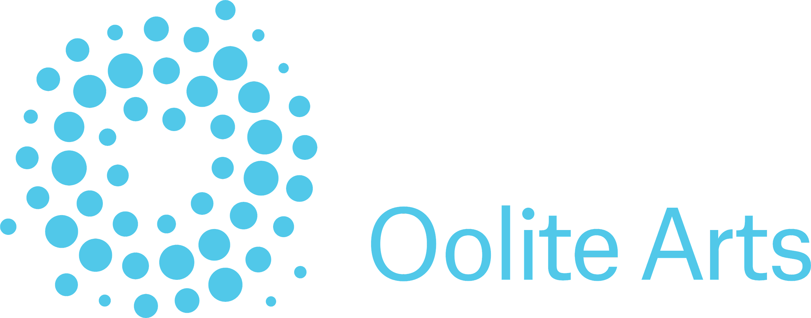
Funding for this program is provided through a grant from Florida Humanities with funds from the National Endowment for the Humanities. Any views, findings, conclusions or recommendations expressed in this (publication) (program) (exhibition) (website) do not necessarily represent those of Florida Humanities or the National Endowment for the Arts.
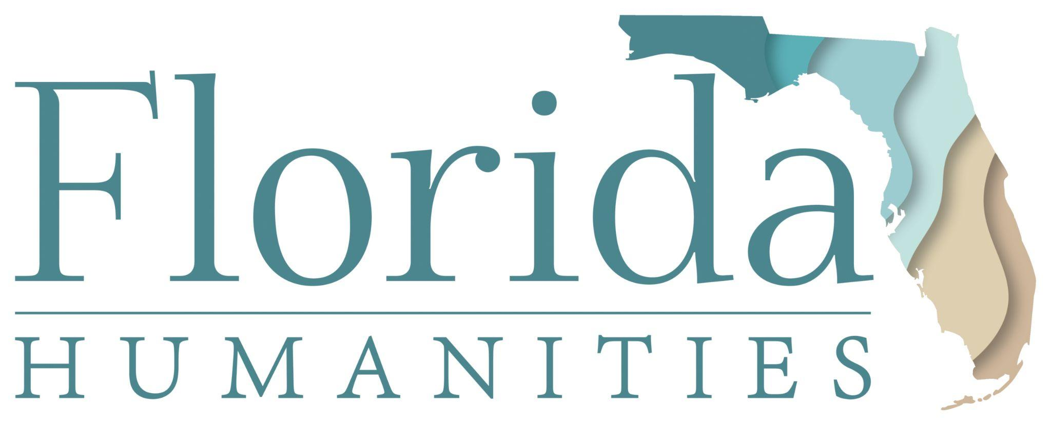
“With the support of the Miami-Dade County Department of Cultural Affairs and the Cultural Affairs Council, the Miami-Dade County Mayor and Board of County Commissioners.”
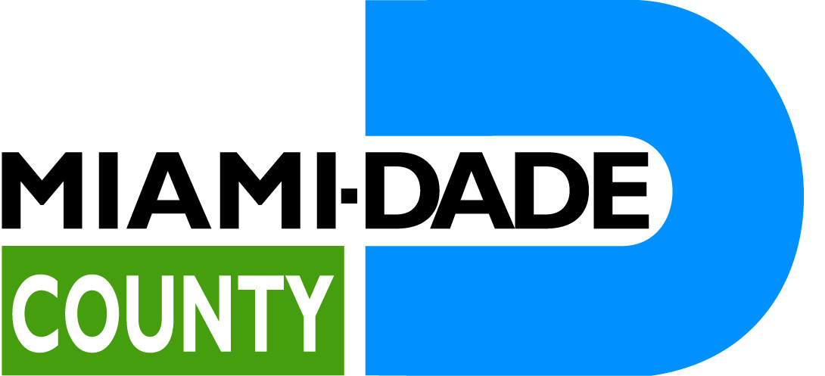
Fabrics World, 7931 SW 40 St. Miami, Florida 33155. Receive a discount by mentioning FAMA.
Art Nexus, ArtNexus is the leading magazine to cover the contemporary art of Latin America.
Malabrigo is a family-owned yarn company located in Uruguay and Peru.

